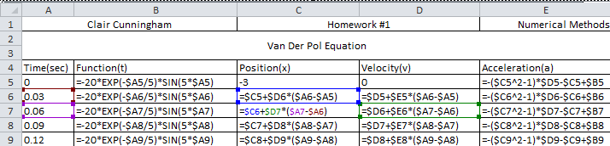

Given the acceleration equation, both the instantaneous velocity and position equation can be found by integrating the equation once and twice respectively.



I found the acceleration at the start time given the starting velocity and position, time, and equations. From that I backed track to find new velocities by multiplying the change in time, dt, by the old acceleration and adding it to the old velocity. Similary I multiplied the new velocity by dt and added it to the old position to find the new position.

%Clair Cunningham Numerical Methods 3/7/2013 Homework #1

%% The driven van der Pol Oscillator

% Evaluates the van der Pol Oscillator equation using the Forward Euler Approach

% Reset variables, close windows, and clear command window.

clear all; close all; clc;

% Initialize Constants and Variables

i = 1;

t = (0:.03:30);

dt = t(2)-t(1);

x(i) = -3; %Starting Position

v(i) = 0; %Starting Velocity

a(i) = 0; %Initliaze Acceleration variable

%Set f(t) all equation values for the limited time.

f_t = -20.*exp(-t./5).*sin(5.*t);

%Run a "for loop" with 1000 intervals since first interval is done

for i = 1:1000

a(i) = -(x(i)^2-1)*v(i)-x(i)+f_t(i);

v(i+1) = v(i)+a(i)*dt;

x(i+1) = x(i)+v(i+1)*dt;

end

%Add the last value of the acceleration to the array

a(i+1) = -(x(i)^2-1)*v(i)-x(i)+f_t(i);

%Graph the representation of the data.

figure(1);

plot(t,x,t,v)

grid on;

title('Driven van der Pol Oscillator');

xlabel('time (sec)');

ylabel('displacement (ft)');

legend('x','v');

